NORTH WHIDBEY FIRE AND RESCUE BOARD OF COMMISSIONERS
Administration Building, 770 NE Midway Blvd. Oak Harbor, WA
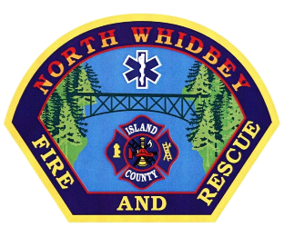
Phone: 360-675-1131 Email: Admin@nwfr.org

Special Meeting Agenda
September 14th, 2021
5:00pm

Approved
Call to Order
Chairman Lamont called the meeting to order at 5:03pm. Also in attendance were Commissioner Koorn, Commissioner Goen, Fire Chief Clark, Operations Chief Swiger and Miranda Engle.

Strategic Planning
NFPA 1582, 1583 and 1720 were discussed. 1720 regarding response time, 6 firefighters within 14 minutes 80% of the time. This is currently not being met with two on duty at a time. Would like to do “Safer”. If “Safer” does not go as planned, we will have to devise an alternative.

IAFC-VCOS Conference, November 10th-17th 2021.

Assess how to get a better response from the public regarding stations and staffing.

Full time, part time and volunteer staff all need to be treated the same.

No decisions made.

Good to the Order
Adjourn Meeting
- There being no further business and my mutual consent, the special meeting of the Board adjourned at 5:42pm.

Attest

_____________________
Miranda Engle

